Homeless and Special Needs Housing
Application Instructions

Virginia Homeless Solutions Program (VHSP)
Housing Opportunities for Persons With AIDS (HOPWA)

Funding Years
July 1, 2024 to June 30, 2025
July 1, 2025 to June 30, 2026

Due Date: April 5, 2024

Homeless and Special Needs Housing Application
The Homeless and Special Needs Housing (HSNH) application is a community-based application for the Virginia Homeless Solutions Program (VHSP) and Housing Opportunities for Persons With AIDS (HOPWA) funding.

Funding Levels
Approximately $17 million dollars (based on anticipated funding levels) funded through HSNH.

The amount of funding received within any continuum of care (CoC) or local planning group (LPG) is based on available funds and the application score that reflects the following:

- Local need;
- Alignment of the approach with state and federal goals;
- Alignment of proposed activities with state goals;
- Local coordination;
- Community and provider capacity; and
- Performance outcomes.

Though applications are CoC/LPG-based, grants are made directly to specific organizations for eligible homeless service programs. There is a minimum contract request amount of $25,000 per grantee; however, DHCD reserves the right to enter into contracts with grantees for less than $25,000.

Match Requirement
Virginia Homeless Solutions Program funds require a 25 percent match based on the total amount of funds allocated to the CoC/LPG, excluding HOPWA funding. This match requirement may be met at the community and/or grantee level, allowing communities to use programs or services funded by local and private resources as a match for this funding. The match must be used to meet the VHSP goals: to reduce the number of persons who become homeless, to shorten the length of time persons are homeless, and to reduce the number of persons that return to homelessness. Match must be received and expended within the grant year and may not be used to meet multiple match requirements.

Application Submission
The HSNH application must be submitted by the CoC/LPG through DHCD’s Centralized Application and Management System (CAMS). Applicants must follow all instructions for submission. Applications will be reviewed and evaluated as submitted. Incomplete applications will negatively affect the final score.

In order to apply for funding, an applicant organization (the CoC/LPG lead organization) must have a registered CAMS organizational profile. Once an organization has an approved profile, individual users may be given access to CAMS by the organization’s profile manager.

The Balance of State CoC local planning groups will be applying as local CoCs. In these cases, the lead organization for each planning group will submit the application for HSNH funding.

Applications may be submitted any time prior to the deadline. DHCD staff will be available for technical assistance during normal business hours. Once an application is submitted, CAMS will send the applicant an email notification to confirm receipt.

Project Information
The applicant must log into CAMS, select the Homeless and Special Needs Housing Application, and apply. When the applicant clicks on Apply, the system will ask for a Project Name. The applicant should enter the name of the CoC/LPG as the project name. Once the applicant clicks Continue, the project name cannot be edited. At this point CAMS will give the application a system-generated Application ID number.

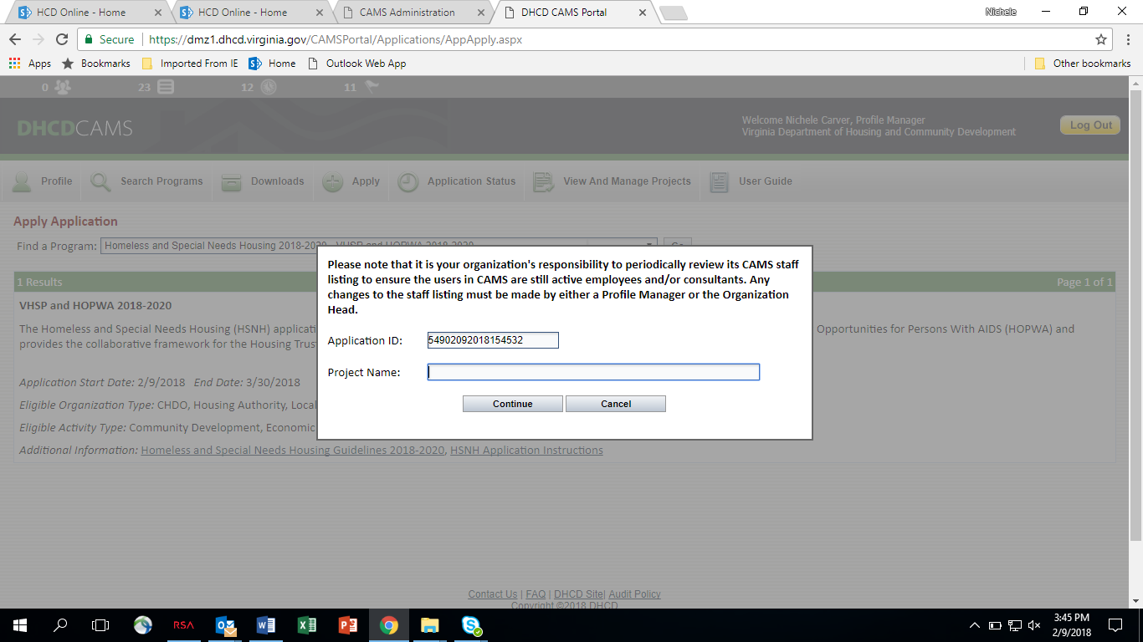

Select Continue and CAMS will take the applicant to the Project Information tab. On the project information tab, the Organization Name will be pre-populated based on the organization’s (CoC/LPG lead organization) profile. Any errors or needed updates to the organizational profile must be made by the individual who is set up as a profile manager for the organization.

On the project information tab, enter the Project Primary Contact information of the individual DHCD should contact with questions regarding the application.

For Place of Primary Performance, enter the location of the lead organization. The Primary Service Area is the locality(s) that are included in the CoC/LPG.

At this point, the page will display a ‘Print’ option at the top right-hand corner. The ‘Print’ function will produce a PDF that can be printed or saved. This will display any information previously entered and saved in the application.

Helpful Tip: To print an application that will display all the questions, go into the “Narrative Information” tab and enter “NA” into each text box. This will allow you to have a copy of the application including all the narrative questions to work on outside of CAMS.
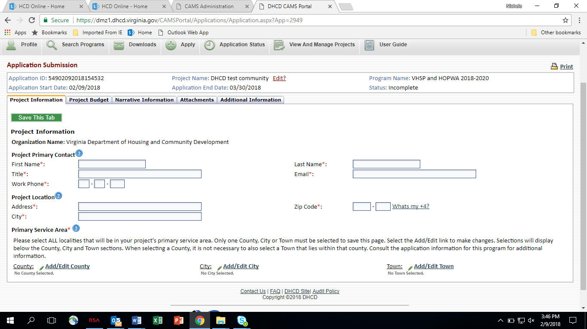

Project Budget
The application will advance to the project budget section. The applicant must enter the total amount of funds being requested for all proposed grantees for each eligible activity category:
- Outreach
- Emergency Shelter Operations
- Centralized or Coordinated Assessment/Entry
- Targeted Prevention
- Rapid Re-housing
- CoC/LPG Planning
- HMIS
- Administrative costs
- HOPWA request

Requests are limited to no more than 5 percent for administration, 5 percent for HMIS, and 10 percent for CoC/LPG planning of the total base funding amount. The base funding includes outreach, emergency shelter operations, rapid re-housing, targeted prevention, and centralized or coordinated assessment/entry.

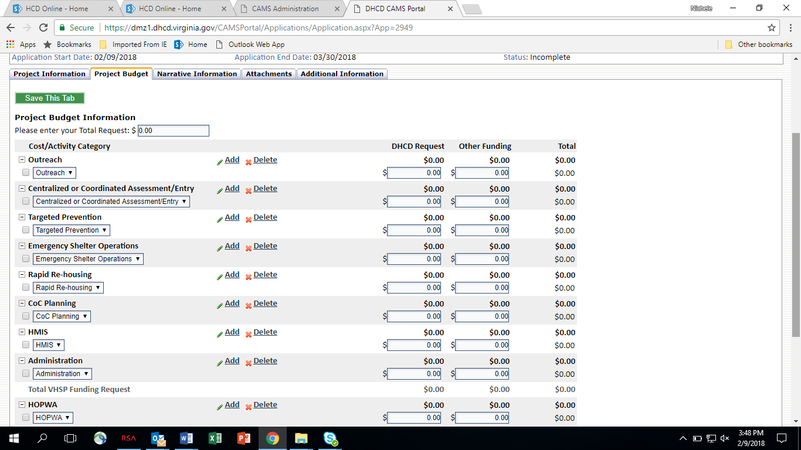

Narrative Information
The applicant will then be advanced to the narrative questions. Text boxes have an approximately 6,000-character limit. DHCD suggests that applicants work in a word processor software and copy and paste into the CAMS text boxes. Word processors allow an applicant to check the spelling and size of the text prior to copying and saving in CAMS. Be aware that there is a timeout feature in CAMS. Applicants will be logged out after 55 minutes of inactivity. DHCD recommends that applicants save frequently to ensure no information is lost. The narrative questions are located on the following page for the applicant’s reference. Once the narrative information is complete, applicants should print the questions by clicking the Print tab at the top of the page and review the document for completeness and accuracy. The applicant is able to edit this information up until the time the application is submitted.

The CAMS text box in this section will only accommodate text responses. Graphs, tables, and charts will appear as text only. The applicant may use the CAMS attachment section to provide any supplement to the narrative text boxes.

HSNH Application Narrative

Community Analysis and Processes

- Based on data from PIT Counts, HMIS/HCIS, and other data sources, who is experiencing or at risk of experiencing homelessness or at risk of homelessness in the CoC/LPG? Include details regarding target population demographics, increases/decreases, and/or those who are especially vulnerable in the service area.

- Describe in detail the CoC/LPG’s Crisis Response System from outreach to permanent housing placement. Include how households access services (phone, walk-in, etc.), after-hours access for emergency services, and how referrals are made. If applicable, how is HOPWA included in the coordinated entry process?

- Identify where gaps exist within the CoC/LPG Crisis Response System to include access to services via coordinated entry and capacity of necessary service interventions such as shelter, prevention, and rapid rehousing. What is the CoC/LPG doing to address these gaps?

- Describe the CoC/LPG’s coordinated entry process to include: how households access services (phone, walk-in, etc.), after-hours access for emergency services, and how referrals are made. If applicable, how is HOPWA included in the coordinated entry process?

- Describe the CoC/LPG’s coordinated entry system’s prioritization process for prevention assistance, emergency shelter placement, and permanent housing placement. How were these prioritization criteria developed? Were these criteria informed by the communities’ needs1? If applicable, include any DHCD-funded HOPWA services in this discussion.

- How is the length of financial and supportive services for households in Rapid Rehousing and Targeted Prevention determined? Is the process determined at the CoC/LPG level or by the individual service provider(s)?

- Are homeless assistance services available to the entire community? Include how the CoC/LPG ensures services for: 1. Households located in all areas of the CoC/LPG service area; 2. Singles/families, men/women, and the following harder to serve populations: sex offenders, large families, medically fragile, LGBTQ+, unaccompanied youth; 3. Households with accessibility concerns including language and mobility; 4. Households with limited or no personal phone or internet access.

- Does the CoC/LPG have any requirements to access services (i.e. birth certificate or photo ID, residency requirement)? What is the purpose of the requirements and what efforts does the CoC/LPG make to assist households in need of services that do not or cannot meet these requirements?

- Are there any existing barriers in the community that would prevent a household from accessing services or permanent housing? What is the CoC/LPG doing to address these barriers?

- Identify membership of the CoC/LPG (list the nonprofit homeless service providers, faith-based organizations, governments, businesses, advocates, school districts, hospitals, law enforcement, etc. that participate in the CoC/LPG). For each entity listed, provide their participation rate in CoC/LPG general meetings over the past calendar year (January 1, 2023 – December 31, 2023). If applicable, what efforts are being made by the CoC/LPG to recruit new members and/or increase participation of existing members?

- How does the CoC/LPG examine its programs and systems for racial disparities? Detail any disparities, how changes that have been put in place to ensure those disparities are not perpetuated, and who participated in the process.

- Discuss the process to determine service providers included in this application. Provide details on any providers who were not selected to be included in this application, including the reason they were not included.

- Describe the level of oversight the CoC/LPG has over the implementation of VHSP- and HOPWA-funded project activities by the service providers. Has the CoC/LPG adopted a formal monitoring process to ensure quality of program service provision and adherence to HSNH and program-specific guidelines? How does the CoC/LPG regularly review the expenditure rates of each service provider to ensure grant funds are used in a timely and efficient manner?

Proposed Grantees (VHSP and HOPWA)
- List the proposed grantees and project types for VHSP and HOPWA funding.

- For each proposed project listed, including HOPWA, describe in detail how the organization implements a Housing First approach. Include specific examples of how the organization implements a Housing First approach such as organizational or programmatic policies, procedures, guidelines, etc.

- For each direct service proposed grantee, does the organization as a whole or specific program for which funding is requested have any rules or requirements for assistance that could act as a barrier to services (i.e. birth certificate or photo ID, residency requirement, participation requirement)? What is the purpose of the requirement(s) and what efforts does the organization make to assist households in need of services that do not or cannot meet the requirement(s)?

- For each proposed grantee, does the agency have the capacity to administer the requested funding? Will project activities be ready to begin on July 1? If not, please detail an expected timeline for activities to begin. If any portion of the funding request is to pay for a new staff position, how will the agency ensure position is filled in a timely manner?

- For each proposed grantee, discuss the capacity of the organization to implement VHSP or HOPWA-funded activities. Provide a list of the applicable certificates of training for direct program staff.

- For fiscal agents and service coordinators only, detail the sub-contracted agencies that will be administering the VHSP- or HOPWA-funded activity(s). Include a discussion of their capacity to carry out the project in adherence with HSNH and program-specific guidelines. How will the agency monitor the funded activities provided by the sub-contracted agencies?

- Proposed HOPWA-providers only, what safeguards and provisions are in place to protect clients’ HIV/AIDS statuses from landlords and other third parties?

- Proposed HOWPA-providers only, detail the other funding sources the agency has access to for housing individuals with HIV/AIDS and which community services are leveraged for HOPWA project participants.

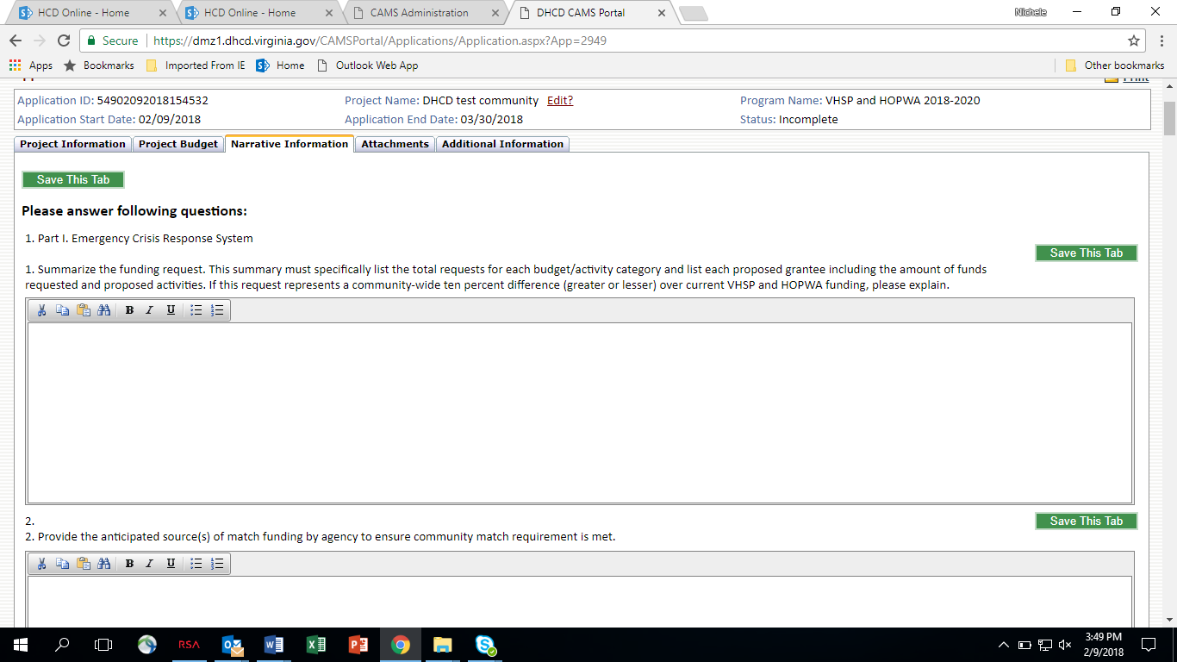

Attachments
Attachments are required for this application. For some, a DHCD-provided template must be used. All attachments are listed on the attachments tab in CAMS. The attachments with required templates have a link next to the name of the attachment and instructions to download.

Other attachments do not require DHCD templates. The CoC or LPG charter/by-laws is an example of an attachment that will not require a DHCD template. In these cases, the applicant will upload an electronic version of the document.

Required Application Attachments
Name of Attachment | Requirement
CoC Certification and Assurances | DHCD template; required for all CoCs/LPGs
Organizational Certification and Assurances | DHCD template; required for all grantees included in the proposed HSNH year one request
Year One Request (by grantee and activity) | DHCD template
CoC Level Policies and Procedures/Service Standards | Applicant document(s)
CoC/LPG Governance Charter/By-laws | Applicant document
CoC/LPG HMIS Policies and Procedures | Applicant document
Job Descriptions (case managers and housing locator positions funded (full or portion) by HSNH) | Applicant document; required for all grantees included in the HSNH year one request
Homeless Services Flow Chart | Applicant document
VHSP Proposed Match Form | DHCD Template
Board of Director Listing | Applicant document; required for all non-profit grantees included in the HSNH year one request
MOU(s) (if applicable) | Applicant document(s)
Additional Attachments | Applicant additional attachments

In some cases, CAMS will provide for only one attachment, such as MOUs. This will require that the applicant save multiple sources of documentation as one document to upload or to submit multiple documents as a zip file.

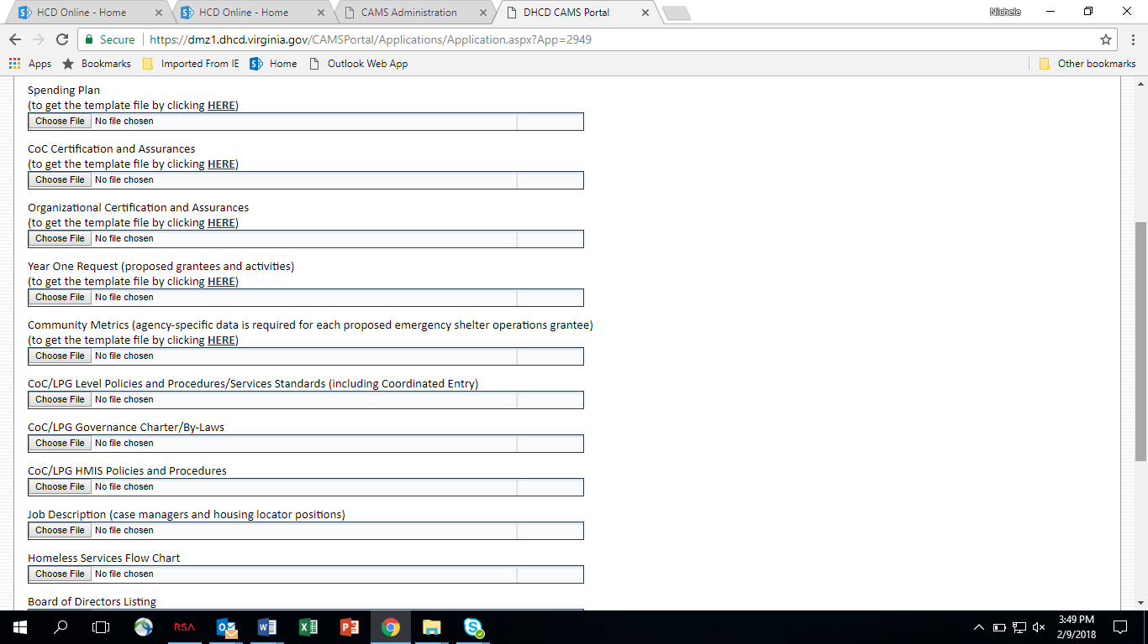

Additional Information
The Additional Information tab allows the applicant to provide additional information not previously requested in the other sections of the application.

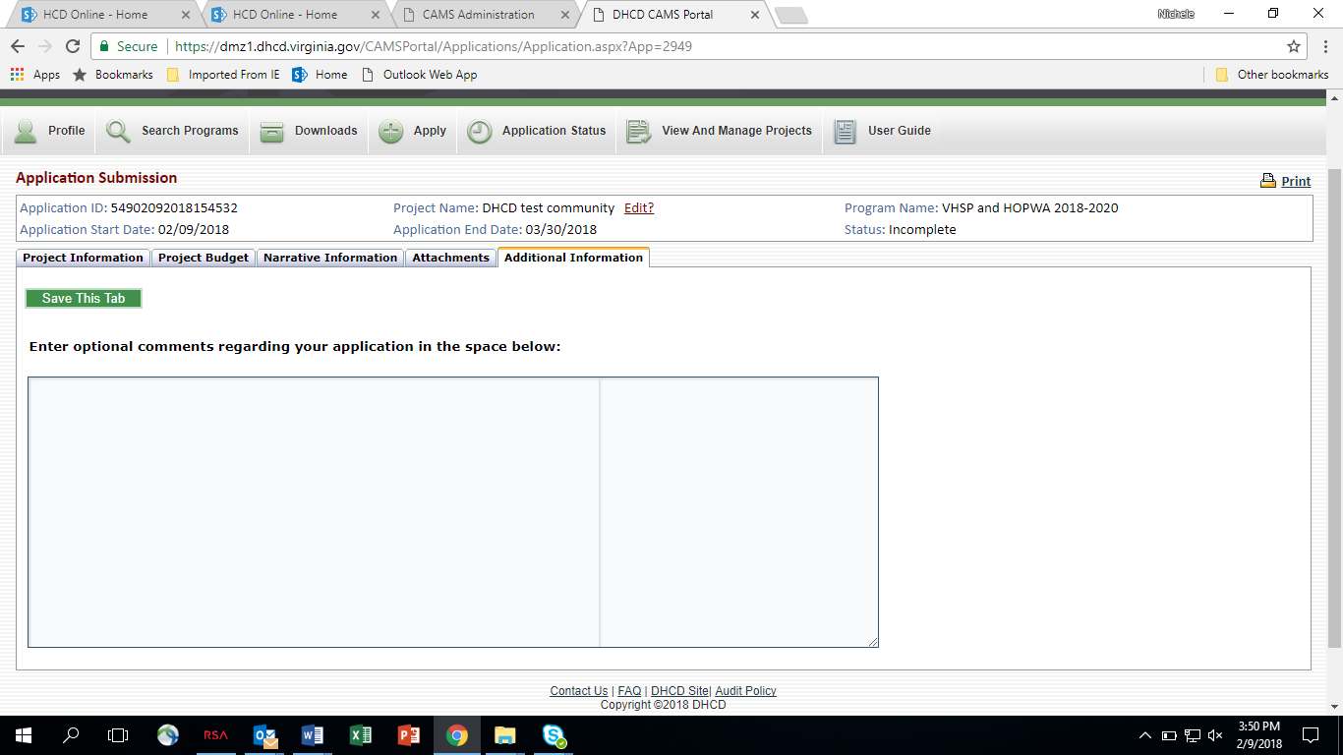

Application Status
Applicants may allow multiple users to edit and review application materials. Applicants are fully responsible for controlling security access to CAMS when the application is submitted to DHCD.

Once the applicant begins work on the application CAMS will save the application as Incomplete. The applicant may return repeatedly to CAMS to work on this application. Please be sure all work on the application is saved in CAMS. The application will remain as an incomplete application until the applicant chooses to submit the application. Once the application is submitted the status will change from Incomplete to Pending.

DHCD Review Process
DHCD conducts panel reviews of all CoC and LPG applications submitted through CAMS.

Applications must score 60 points out of a possible 100 to be considered for funding. All funding requests must be justified by the application. Scoring criteria are as follows:

  - Community Need and Performance Outcomes – 25 points
  - Community Response Approach and Local Coordination – 50 points
  - Capacity of Local Service Providers – 25 points

Applications will be reviewed and evaluated as submitted. Incomplete applications will negatively affect the final score.

DHCD reserves the right to fund CoCs and LPGs scoring below the 60-point threshold to ensure statewide access to HSNH funding. In such cases, funding may be contingent upon CoC/LPG and grantee participation in DHCD technical assistance site visits and training.

Grantees with unresolved findings from a previous DHCD monitoring, audit findings, or other compliance issues may not be eligible for a funding commitment.

Actual funding will be based on the following:
- Requested amount
- Available funds
- Application score

Applications will be scored lower if ineligible activities or activities that are not aligned with state and federal goals to prevent and end homelessness are proposed. Lower scores will impact actual funding levels. Requests will be reduced based on available funding, ineligible activities, activities not in alignment with state and federal goals, and/or where proposed grantees are either ineligible or lack the capacity to carry out proposed activities. DHCD anticipates negotiations with each CoC or local planning group in order to make needed adjustments to proposed activities and budgets.

How to Apply - Webinars
DHCD will review application instructions during the “How to Apply” webinars to be held on:

Tuesday, February 13 (11:00AM to 12:00PM)

Friday, February 16 (11:00AM to 12:00PM)

Questions
Contact Will Kerner at (804) 659-2587 or william.kerner@dhcd.virginia.gov

